Event Capture, Propagation, Bubbling and Once

Objective : of the project is to understand about javascript concepts like ->
event capture, propagation, bubbling and once. These concepts are very
useful in some edge cases of event listener.

Learning :

Bubbling : adding event listener in inner item, cause the event handler to opertate
with parent element too,

How to avoid :
event.stopPropagation() // stops propagation of current handler
event.stopImmediatePropagation() // stops for all

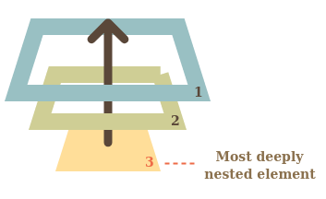

Event delegation
Bubbling also allows us to take advantage of event delegation — this concept relies on the fact that if you want some code to run when you select any one of a large number of child elements, you can set the event listener on their parent and have events that happen on them bubble up to their parent rather than having to set the event listener on every child individually. Remember, bubbling involves checking the element the event is fired on for an event handler first, then moving up to the element's parent, etc.
A good example is a series of list items — if you want each one to pop up a message when selected, you can set the click event listener on the parent <ul>, and events will bubble from the list items to the <ul>.
This concept is explained further on David Walsh's blog, with multiple examples — see How JavaScript Event Delegation Works.

Capturing :
There’s another phase of event processing called “capturing”. It is rarely used in real code, but sometimes can be useful.
The standard DOM Events describes 3 phases of event propagation:
- Capturing phase – the event goes down to the element.
- Target phase – the event reached the target element.
- Bubbling phase – the event bubbles up from the element.
Here’s the picture of a click on <td> inside a table, taken from the specification:

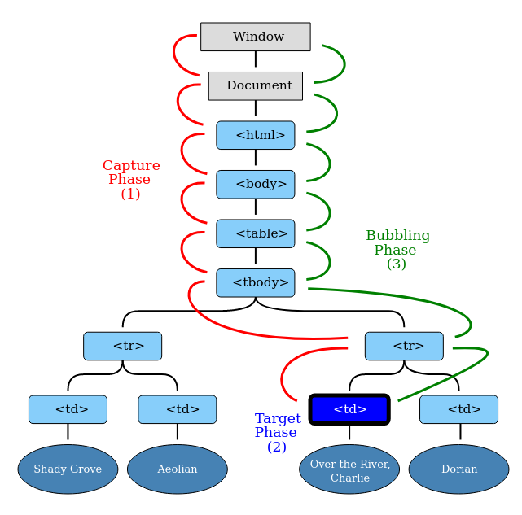

Once function :

The Function.prototype.apply() method allows you to call a
function with a given this value ( reference in which function needs to be called)
and arguments provided as an array.

function once(fn, context) {
var result;

return function () {
if (fn) {
console.log(this);
result = fn.apply(context || this, arguments);
fn = null;
}
return result;
};
}
var canOnlyFireOnce = once(function () {
console.log("Fired!");
});

What is meant by this variable in once function​?

Soln. : ‘this’ refers to the reference with which function is being called.
the this references the object that is currently calling the function.

In JavaScript, you can use the this keyword in the
global and function contexts. Moreover, the behavior
of the this keyword changes between strict and
non-strict mode.

Return Value: It returns the method values of a given function.
Note : here return function(){} this is the main concept. On executing,
var canOnlyFireOnce = once(fn); // this returns a function, let say it X.

Function X execute fine in first term, during first call, it makes itself null,
thus it is unable to call again.

This is undigestible to me as well. More research is needed.

Summary of the topic:
Object.addEventListener(event, function, {capture : false / true, once : true/false});

event :

function :

{capture : true ( it implies that event handler is executed in capturing phase),
false ( default, the event handler is executed in bubbling phase)
once : true ( it implies that function will execute only once )
false ( default, it implies that it will execute as many time it is called ) }

